Project Title:
Nutrition Assistant
Submitted By:
Team Member: Nunna.Sneha
Roll No:24485A4208

Project Report Formate
1. INTRODUCTION
1.1 Project Overview
1.2 Purpose
2. IDEATION PHASE
2.1 Problem Statement
2.2 Empathy Map Canvas
2.3 Brainstorming
3. REQUIREMENT ANALYSIS
3.1 Customer Journey map
3.2 Solution Requirement
3.3 Data Flow Diagram
3.4 Technology Stack
4. PROJECT DESIGN
4.1 Problem Solution Fit
4.2 Proposed Solution
4.3 Solution Architecture
5. PROJECT PLANNING & SCHEDULING
5.1 Project Planning
6. FUNCTIONAL AND PERFORMANCE TESTING
6.1 Performance Testing
7. RESULTS
7.1 Output Screenshots
8. ADVANTAGES & DISADVANTAGES
9. CONCLUSION
10. FUTURE SCOPE
11. APPENDIXSource Code(if any),Dataset Link,GitHub & Project Demo Link

1. INTRODUCTION
Proper nutrition is essential for maintaining good health, improving immunity, and preventing lifestyle-related diseases. However, due to busy schedules, unhealthy eating habits, and a lack of nutritional awareness, many individuals find it difficult to maintain a balanced diet. Most people rely on general diet plans available on the internet, which may not suit their individual health conditions, dietary preferences, or fitness goals. This creates a need for a digital solution that can provide personalized nutrition guidance in a simple and accessible manner.
The Nutrition Assistant is a Full Stack MERN web application developed to help users make healthier food choices through personalized nutrition recommendations. The application provides an interactive platform where users can register, log in securely, manage their profiles, and receive customized dietary suggestions based on their health information and goals. The system is designed to simplify nutrition planning and promote healthy eating habits using modern web technologies.
The project is developed using the MERN Stack, which includes MongoDB for database management, Express.js and Node.js for backend development, and React.js for building a responsive and interactive user interface. The frontend communicates with the backend through RESTful APIs, while MongoDB securely stores user information and application data. This architecture ensures efficient data management, faster performance, and scalability.

1.1 Project Overview
The Nutrition Assistant is a web-based Full Stack MERN application that provides users with personalized nutrition guidance through an intuitive and responsive interface. The primary objective of the project is to help users maintain a healthy lifestyle by offering customized meal recommendations and nutrition-related information based on their individual requirements.
The application allows users to create an account, log in securely, and access various nutrition-related features. Users can provide personal information such as age, gender, height, weight, dietary preferences, and health goals. Based on these details, the system generates suitable nutrition recommendations that help users improve their eating habits and overall well-being.
The frontend of the application is developed using React.js, HTML, CSS, and JavaScript to create a responsive and interactive user experience. The backend is developed using Node.js and Express.js, which handle business logic, user authentication, API requests, and communication with the database. MongoDB is used to store user profiles, nutritional information, and application data securely.
RESTful APIs enable smooth communication between the frontend and backend, allowing users to retrieve and update information efficiently. Git and GitHub are used for version control, enabling proper management of the project source code throughout the development process.

1.2 Purpose
The primary purpose of the Nutrition Assistant is to develop a user-friendly web application that provides personalized nutritional guidance and promotes healthy eating habits. The application is designed to help users make informed dietary decisions by offering customized recommendations based on their personal health information and nutrition goals.
The objectives of the project are as follows:
- To develop a responsive Full Stack web application using the MERN Stack.
- To provide users with personalized nutrition recommendations based on their health information.
- To promote healthy eating habits and balanced diets.
- To enable secure user registration and authentication.
- To store user information safely using MongoDB.
- To establish efficient communication between the frontend and backend using RESTful APIs.
- To create an attractive and responsive user interface using React.js.
- To improve user experience through simple navigation and interactive design.
- To demonstrate the practical implementation of Full Stack Web Development concepts.
- To encourage healthier lifestyle choices through technology-based nutritional guidance.

2. IDEATION PHASE
The idea for the Nutrition Assistant project emerged from the growing awareness of the importance of maintaining a healthy lifestyle through proper nutrition. In today's fast-paced world, many individuals struggle to follow balanced diets because of busy schedules, lack of nutritional knowledge, and limited access to personalized dietary guidance. Most people depend on general diet charts or online information, which may not suit their individual health conditions and fitness goals.

2.1 Problem Statement
Maintaining a healthy diet has become increasingly difficult due to changing lifestyles, work pressure, unhealthy eating habits, and the availability of processed foods. Many individuals are unable to identify the right nutritional requirements based on their age, body condition, lifestyle, and personal health goals. Existing diet plans are usually generalized and may not provide personalized recommendations suitable for every individual.

2.2 Empathy Map Canvas
The Empathy Map Canvas was prepared to better understand the needs, expectations, and challenges faced by users who seek nutritional guidance.

What the User Says
- I want to maintain a healthy lifestyle.
- I don't know which foods are suitable for my body.
- I need a simple application that provides nutrition guidance.
- I want personalized meal recommendations instead of general diet plans.

What the User Thinks
- Will this diet help me achieve my health goals?
- Is the recommended meal suitable for my body condition?
- Can I trust the nutrition information provided by the application?
- I need an easy way to plan my daily meals.
The empathy map helped identify user expectations and guided the development of features that provide a better user experience and practical nutrition guidance.

2.3 Brainstorming
During the brainstorming phase, different ideas were discussed to determine the most effective solution for improving nutritional awareness and assisting users in maintaining healthy eating habits.
Several possible solutions were considered, including:
- Developing a digital nutrition guide.
- Creating a calorie tracking application.
- Building a healthy meal planner.
- Designing a food recommendation system.
- Developing a personalized nutrition management platform.
After evaluating these ideas, the team decided to develop the Nutrition Assistant, a Full Stack MERN web application that combines multiple nutrition-related features into a single platform.
The proposed solution focuses on:
- Providing personalized nutrition recommendations.
- Secure user registration and authentication.
- Managing user profiles and health information.
- Delivering customized meal suggestions.
- Creating a responsive and user-friendly interface.
- Ensuring secure storage of user data using MongoDB.
- Improving accessibility through a modern web application.

3. REQUIREMENT ANALYSIS
Requirement Analysis is one of the most important phases in software development. In this phase, the functional and non-functional requirements of the Nutrition Assistant application are identified and analyzed. The goal is to understand the needs of users, define the system's functionalities, and ensure that the final application satisfies all project objectives. Proper requirement analysis helps reduce development risks and improves the overall quality of the application.
The Nutrition Assistant application is designed to provide users with an easy and secure platform for managing their nutritional information, meal plans, and health progress. The system supports user authentication, personalized meal planning, nutrition tracking, and progress monitoring while maintaining data security and scalability.

3.1 Solution Requirement
The Nutrition Assistant requires both functional and non-functional requirements to ensure smooth operation and a better user experience.

Functional Requirements:
The application must provide the following functionalities:
- User Registration
- Secure User Login
- JWT-based Authentication
- Password Encryption using bcrypt
- Create User Profile
- Add Meal Plans
- Edit Meal Plans
- Delete Meal Plans
- View Meal Plans
- Track Nutrition Progress
- Dashboard for Monitoring Daily Nutrition
- Admin Management (Optional)
- MongoDB Database Connectivity
- REST API Integration
- Logout Functionality

Non-Functional Requirements
The application should satisfy the following quality requirements:
- High Performance
- Fast Response Time
- Secure Data Storage
- Responsive User Interface
- Easy Navigation
- Scalability
- Reliability
- Maintainability
- Cross-browser Compatibility
- Data Validation

3.2 Data Flow Diagram (DFD)
The Data Flow Diagram illustrates how information moves through the Nutrition Assistant application.

Level-0 DFD
+----------------+
| User |
+--------+-------+
|
Register/Login
|
V
+---------------------------+
| Nutrition Assistant |
+---------------------------+
| Authentication Module |
| Meal Plan Module |
| Progress Tracking Module |
+-------------+-------------+
|
|
MongoDB Database.

3.3 Technology Stack
The Nutrition Assistant is developed using modern web technologies that provide scalability, security, and performance.
Technology | Purpose
HTML5 | Structure of Web Pages
CSS3 | Styling and Responsive Design
JavaScript | Client-side Programming
React.js | Frontend Development
Node.js | Backend Runtime Environment
Express.js | REST API Development
MongoDB | NoSQL Database
Mongoose | Database Modeling
JWT | User Authentication
bcrypt | Password Encryption
Axios | API Communication
Thunder Client / Postman | API Testing
VS Code | Code Editor
Git | Version Control
GitHub | Source Code Repository

Why MERN Stack?
The MERN Stack provides complete JavaScript development from frontend to backend. It reduces development complexity, improves maintainability, and enables faster application development.

3.4 System Requirements

Software Requirements
The following software components are required to develop and run the Nutrition Assistant application:
Software | Version
Windows 10/11 | Operating System
Node.js | Version 16 or Above
npm | Version 8 or Above
React.js | Latest
Express.js | Latest
MongoDB Atlas | Cloud Database
Visual Studio Code | IDE
Thunder Client / Postman | API Testing
Git | Version Control
GitHub | Code Repository
Google Chrome | Web Browser

Hardware Requirements
Component | Specification
Processor | Intel Core i5 / AMD Ryzen 5 or Above
RAM | Minimum 8 GB
Storage | Minimum 1 GB Free Space
Internet | Required for MongoDB Atlas
Display | 1366 × 768 or Higher

4. PROJECT DESIGN
Project Design is the phase where the requirements identified during the analysis phase are transformed into a structured solution. It defines how the Nutrition Assistant application is organized, how different modules interact with each other, and how data flows throughout the system. A well-designed architecture improves scalability, maintainability, security, and overall application performance.
The Nutrition Assistant is designed using the MERN Stack (MongoDB, Express.js, React.js, and Node.js) following a modular architecture. The application consists of a React frontend, an Express.js and Node.js backend, and a MongoDB database. Each module performs a specific function while communicating through RESTful APIs to provide a smooth and secure user experience.

4.1 Problem Solution Fit
The Nutrition Assistant project is designed to solve the common challenges faced by users in maintaining a healthy diet and tracking their nutrition. Traditional methods of recording meals and calories are often time-consuming, inaccurate, and difficult to maintain. Many existing systems also lack secure authentication and personalized nutrition management.
The proposed solution addresses these problems by providing a centralized web application where users can securely register, log in, create personalized meal plans, monitor calorie intake, and track their nutritional progress. The use of MongoDB enables efficient data storage, while React.js provides a responsive and user-friendly interface. Express.js and Node.js handle backend operations and RESTful APIs, ensuring smooth communication between the frontend and the database.

Problem vs Solution
Existing Problem | Proposed Solution
Manual nutrition tracking | Digital nutrition management system
Insecure user data | JWT authentication and bcrypt encryption
Difficulty managing meal plans | Personalized meal planning module
Lack of progress monitoring | Interactive progress tracking dashboard
Poor accessibility | Responsive web application
Scattered data | Centralized MongoDB database

4.2 Proposed Solution
The proposed Nutrition Assistant is a secure, responsive, and scalable full-stack web application developed using the MERN Stack.
The application allows users to create an account, log in securely, manage personal profiles, create customized meal plans, and monitor daily nutritional intake. All user information is stored securely in MongoDB. Passwords are encrypted using bcrypt, and user authentication is managed using JSON Web Tokens (JWT).
The frontend, developed using React.js, provides an interactive dashboard where users can easily navigate through different modules such as meal planning, nutrition tracking, and progress monitoring. Axios is used to communicate with the backend APIs, ensuring efficient data exchange.
The backend, developed with Node.js and Express.js, handles user authentication, API requests, business logic, and database operations. The application follows a modular structure, making it easy to maintain and extend with additional features in the future.

Key Features
- User Registration
- Secure Login using JWT
- Password Encryption using bcrypt
- Personalized Meal Planning
- Nutrition Tracking
- Progress Monitoring
- Responsive Dashboard
- RESTful API Integration
- MongoDB Database Storage
- Secure Role-Based Architecture (if extended)

4.3 Solution Architecture
The Nutrition Assistant follows a three-tier architecture consisting of the Presentation Layer, Application Layer, and Database Layer.

Architecture Explanation
Presentation Layer (Frontend):
The frontend is developed using React.js, HTML, CSS, and JavaScript. It provides user interfaces for registration, login, dashboard, meal planning, and nutrition tracking. Users interact with the system through this layer.
Application Layer (Backend):
The backend is developed using Node.js and Express.js. It processes user requests, validates input, performs authentication, executes business logic, and communicates with the database through REST APIs.
Database Layer:
MongoDB stores all application data, including user profiles, meal plans, nutritional information, and progress records. Mongoose is used for database modeling and data validation.

Solution Architecture Diagram
+----------------------+
| User |
+----------+-----------+
|
|
V
+----------------------------+
| React.js Frontend |
| (HTML, CSS, JavaScript) |
+-------------+--------------+
|
Axios REST APIs
|
V
+----------------------------+
| Node.js + Express.js API |
| Authentication & Business |
| Logic |
+-------------+--------------+
|
Mongoose
|
V
+----------------------------+
| MongoDB Database |
| Users | MealPlans | |
| Progress | Profiles |
+----------------------------+

Architecture Benefits
- Modular application structure.
- Secure communication between client and server.
- Efficient database management using MongoDB.
- Scalable backend with Express.js.
- Responsive and interactive frontend using React.js.
- Easy maintenance and future enhancements.
- RESTful API-based communication.
- Improved performance through optimized data flow.

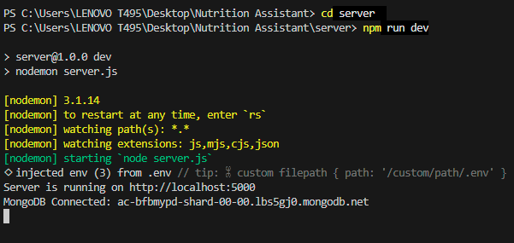
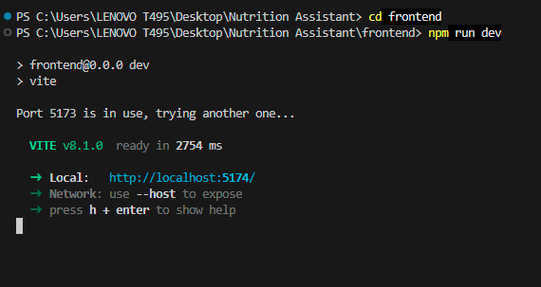

5. PROJECT PLANNING & SCHEDULING
Project Planning and Scheduling is an essential phase in software development that helps organize the entire project into manageable tasks. It defines the sequence of activities, allocates resources, estimates the required time, and ensures that the project is completed within the planned schedule. Proper planning minimizes risks, improves productivity, and enables effective monitoring of project progress.
For the Nutrition Assistant project, planning was carried out by dividing the development process into multiple phases, including requirement analysis, system design, backend development, frontend development, database integration, testing, deployment, and documentation. Each phase was assigned a specific timeline to ensure systematic development and timely completion.
The project follows the Software Development Life Cycle (SDLC), where every phase contributes to building a secure, scalable, and user-friendly nutrition management application.

5.1 Project Planning
The Nutrition Assistant project was planned in a structured manner to ensure smooth execution of all development activities. The project was divided into several phases, beginning with understanding the problem statement and gathering requirements. Based on these requirements, the system architecture and database design were prepared.
The backend development focused on creating RESTful APIs using Node.js and Express.js, implementing JWT authentication, password encryption using bcrypt, and establishing secure communication with MongoDB. Simultaneously, the frontend was developed using React.js to create responsive user interfaces for user registration, login, meal planning, nutrition tracking, and dashboard management.
After integrating the frontend and backend, the application underwent functional testing, API testing using Thunder Client/Postman, and database validation using MongoDB Atlas. Finally, documentation and deployment activities were completed.

Project Development Schedule
Phase | Activity | Duration
Phase 1 | Requirement Analysis and Problem Identification | 1 Week
Phase 2 | Project Design and Architecture Planning | 1 Week
Phase 3 | Database Design using MongoDB | 1 Week
Phase 4 | Backend Development using Node.js and Express.js | 2 Weeks
Phase 5 | Frontend Development using React.js | 2 Weeks
Phase 6 | Integration of Frontend, Backend, and Database | 1 Week
Phase 7 | Testing and Bug Fixing | 1 Week
Phase 8 | Documentation and Final Deployment | 1 Week

Project Workflow
The project execution follows the sequence below:
Requirement Analysis
↓
System Design
↓
Database Design
↓
Backend Development
↓
Frontend Development
↓
API Integration
↓
Authentication & Security
↓
Testing & Validation
↓
Deployment
↓
Documentation

Resource Planning
The following resources were utilized during the development of the Nutrition Assistant project:
Resource | Purpose
Visual Studio Code | Source Code Development
React.js | Frontend Development
Node.js | Backend Runtime
Express.js | REST API Development
MongoDB Atlas | Cloud Database
Git & GitHub | Version Control
Thunder Client / Postman | API Testing
Google Chrome | Application Testing

Risk Management
Several potential risks were identified during project planning, and appropriate mitigation strategies were adopted.
Risk | Mitigation Strategy
Database connection issues | Verified MongoDB Atlas configuration and tested connectivity
Authentication failures | Implemented JWT authentication and bcrypt password encryption
API communication errors | Tested APIs using Thunder Client and validated responses
Invalid user input | Added frontend and backend validation
Data loss | Used MongoDB Atlas cloud storage and regular backups
Performance issues | Optimized MongoDB queries and React components

Milestones Achieved
The following milestones were completed during the project development:
- Requirement gathering and analysis completed.
- System architecture and database design prepared.
- User registration and login modules implemented.
- JWT-based authentication integrated.
- Meal planning and nutrition tracking modules developed.
- MongoDB database successfully connected.
- RESTful APIs created and tested.
- Frontend integrated with backend services.
- Application tested for functionality and performance.
- Documentation prepared and project finalized.

6. FUNCTIONAL AND PERFORMANCE TESTING
Testing is a crucial phase in the Software Development Life Cycle (SDLC) that ensures the application functions correctly and meets the specified requirements. The purpose of testing is to identify and fix errors before the application is deployed. In the Nutrition Assistant project, both functional testing and performance testing were carried out to verify that all modules operate efficiently, securely, and reliably.
The application was tested to ensure proper functioning of user registration, login, meal plan management, nutrition tracking, database connectivity, and API communication. Various test cases were executed to validate user inputs, backend responses, and frontend functionality. Thunder Client was used to test RESTful APIs, while MongoDB Atlas was used to verify data storage and retrieval.

6.1 Performance Testing
Performance testing evaluates how efficiently the Nutrition Assistant application performs under normal operating conditions. It verifies response time, system stability, database performance, and API execution speed.
The application was tested using different user scenarios, including user registration, login, meal plan creation, data retrieval, and progress tracking. MongoDB queries were optimized to reduce response time, and REST APIs were validated to ensure fast communication between the frontend and backend.
The React frontend was also tested for responsiveness across different screen sizes and browsers. Overall, the application demonstrated stable performance with minimal response time and efficient resource utilization.

Functional Test Cases
Test Case | Input | Expected Result | Status
User Registration | Valid Name, Email, Password | User registered successfully | Pass
Duplicate Registration | Existing Email | Displays "User already exists" | Pass
User Login | Valid Email and Password | Login successful with JWT token | Pass
Invalid Login | Wrong Password | Displays "Invalid Password" | Pass
Meal Plan Creation | Valid Meal Details | Meal plan stored in MongoDB | Pass
Meal Plan Update | Updated Meal Information | Meal plan updated successfully | Pass
Meal Plan Deletion | Delete Request | Meal plan removed successfully | Pass
Nutrition Progress | Valid Nutrition Data | Progress updated successfully | Pass
Database Connection | MongoDB Atlas | Data stored and retrieved correctly | Pass
Logout | Logout Request | User session terminated | Pass

Performance Evaluation
Parameter | Result
Application Startup | Successful
API Response Time | Less than 2 Seconds
Database Connectivity | Stable
Authentication Speed | Fast
Frontend Loading | Responsive
Backend Processing | Efficient
Memory Usage | Optimized
Browser Compatibility | Chrome, Edge, Firefox
Database Operations | Successful
Overall Performance | Excellent

API Testing
REST APIs were tested using Thunder Client to verify request and response handling.
The following APIs were successfully tested:
- User Registration API
- User Login API
- Create Meal Plan API
- View Meal Plans API
- Update Meal Plan API
- Delete Meal Plan API
- Nutrition Progress API
Each API returned appropriate HTTP status codes such as 200 OK, 201 Created, 400 Bad Request, and 500 Internal Server Error whenever necessary. Proper validation ensured that invalid data was rejected and meaningful error messages were displayed.

Database Testing
MongoDB Atlas was tested to verify that all user and nutrition-related data was stored accurately.
The following database operations were validated:
- User information stored successfully.
- Passwords encrypted using bcrypt.
- Meal plans inserted correctly.
- User progress updated successfully.
- Data retrieved efficiently using MongoDB queries.
- CRUD operations executed without errors.

Security Testing
Security testing was conducted to ensure that user information remained protected.
The following security measures were verified:
- JWT authentication working correctly.
- Passwords encrypted using bcrypt.
- Unauthorized users cannot access protected routes.
- Input validation prevents invalid data.
- Secure communication between frontend and backend.

7. RESULTS
The Nutrition Assistant application was successfully designed and developed using the MERN Stack (MongoDB, Express.js, React.js, and Node.js). The application integrates frontend, backend, and database components to provide a secure and user-friendly platform for nutrition management.
The project achieved all the planned objectives, including secure user authentication, meal plan management, nutrition tracking, and progress monitoring. The frontend provides an interactive and responsive interface, while the backend efficiently processes user requests and communicates with the MongoDB database through RESTful APIs.
The application successfully allows users to register, log in, manage their meal plans, monitor nutritional intake, and view their progress. User information is securely stored using MongoDB, and passwords are encrypted using bcrypt to ensure data security. JWT authentication protects user sessions and restricts unauthorized access to protected resources.

7.1 OUTPUT SCREENSHOTS
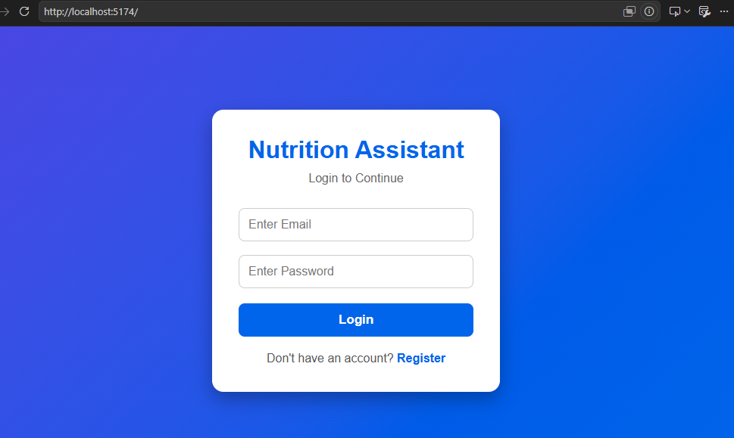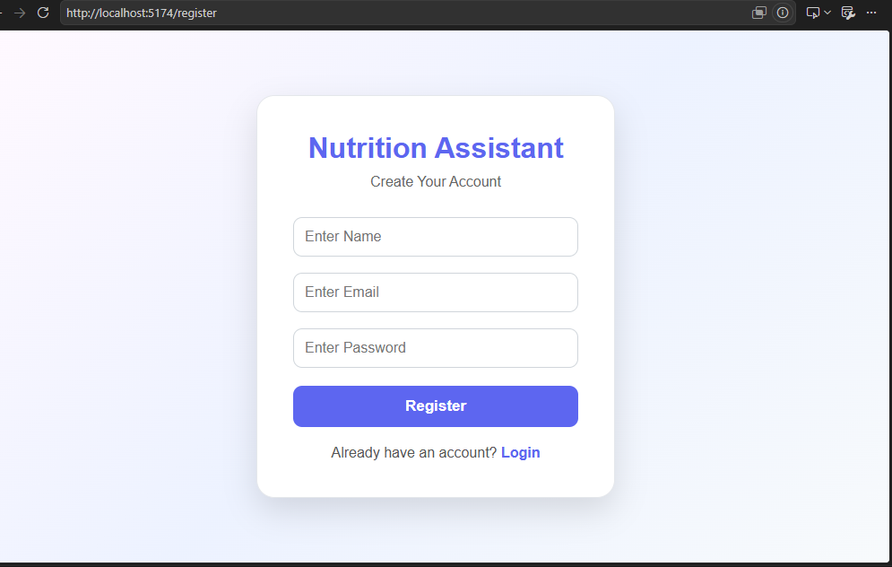

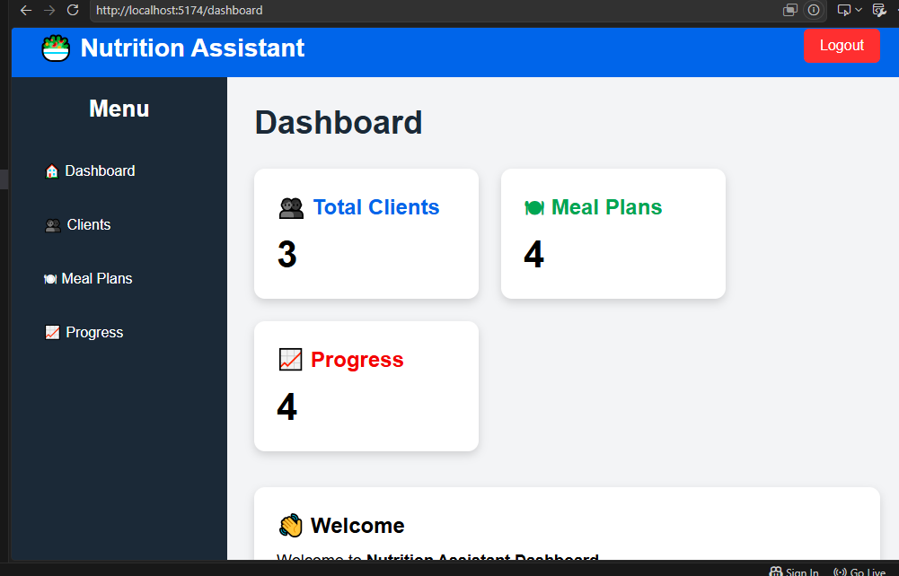

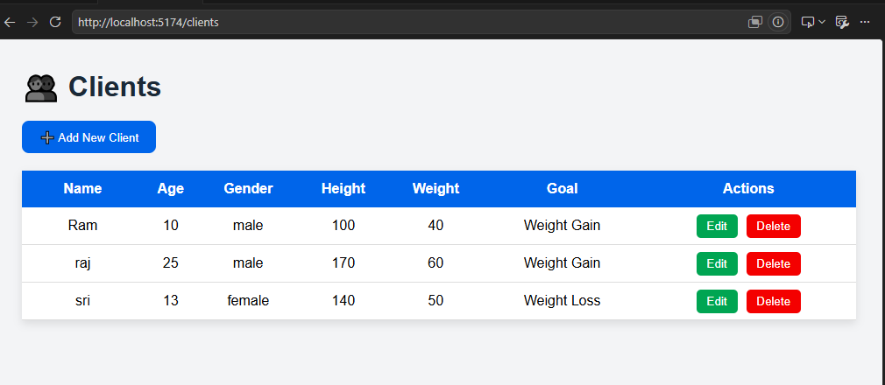

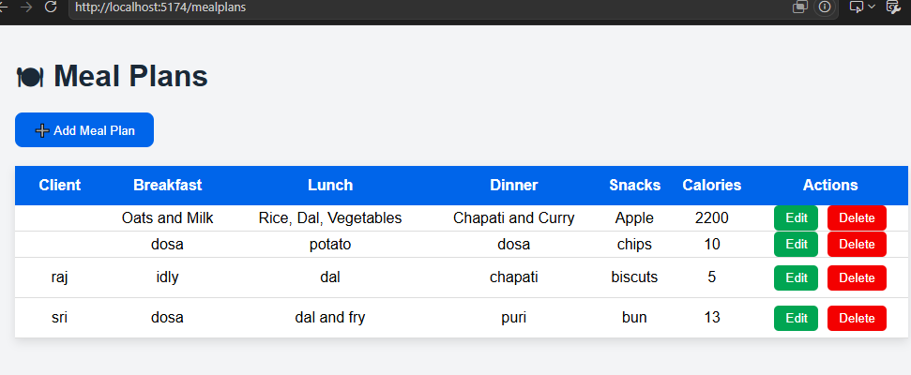

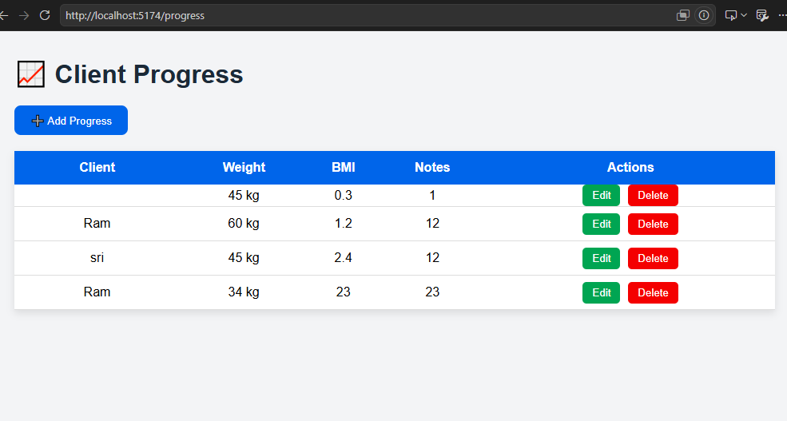

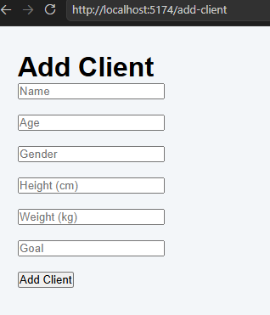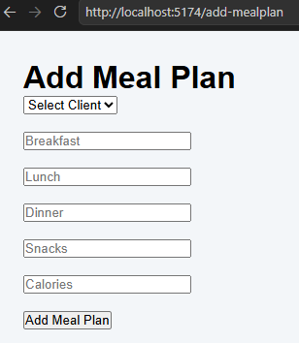

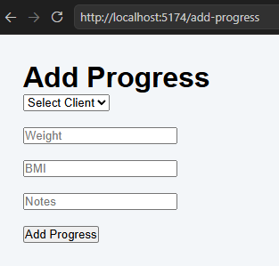

8. ADVANTAGES & DISADVANTAGES
The Nutrition Assistant is a modern web application designed to simplify nutrition management and promote healthy eating habits. Developed using the MERN Stack (MongoDB, Express.js, React.js, and Node.js), the application provides users with a secure, efficient, and user-friendly platform for managing meal plans and tracking nutritional progress. While the system offers many benefits, it also has a few limitations that can be addressed in future versions.

8.1 Advantages
The Nutrition Assistant provides several advantages to both users and administrators. Some of the major benefits are listed below.

1. Secure User Authentication
The application uses JWT (JSON Web Token) for authentication and bcrypt for password encryption. This ensures that user accounts and personal information remain secure.

2. Personalized Meal Planning
Users can create and manage personalized meal plans according to their health goals, making nutrition management simple and organized.

3. Nutrition Progress Tracking
The system allows users to monitor their daily nutritional intake and track their progress over time. This helps users maintain healthy eating habits.

4. Responsive User Interface
The React.js frontend provides a responsive design that works efficiently on desktops, laptops, tablets, and mobile devices.

5. Efficient Database Management
MongoDB stores user information, meal plans, and nutrition records efficiently, ensuring fast retrieval and reliable data storage.

8.2 Disadvantages
Although the Nutrition Assistant provides many useful features, there are some limitations.

1. Internet Dependency
The application requires an active internet connection to communicate with the backend server and MongoDB Atlas database.

2. No AI-Based Recommendations
The current version does not provide intelligent food recommendations based on user preferences or health conditions.

3. Limited Health Metrics
The application mainly focuses on meal planning and nutrition tracking. Advanced health metrics such as BMI analysis, blood sugar monitoring, and fitness integration are not included.

4. No Mobile Application
The project is currently developed as a web application. A dedicated Android or iOS application is not available.

5. Manual Data Entry
Users must manually enter meal and nutrition information, which may take additional time.

9. CONCLUSION
The Nutrition Assistant project was successfully designed and developed as a full-stack web application using the MERN Stack, which includes MongoDB, Express.js, React.js, and Node.js. The primary objective of this project was to provide users with a secure, efficient, and user-friendly platform for managing their nutrition and maintaining healthy eating habits.
The application successfully implements essential features such as user registration, secure login using JWT authentication, password encryption with bcrypt, personalized meal planning, nutrition tracking, and progress monitoring. These features enable users to manage their dietary information efficiently while ensuring the privacy and security of their personal data.
The frontend of the application, developed using React.js, provides a responsive and interactive user interface that enhances the overall user experience. The backend, built with Node.js and Express.js, efficiently handles business logic, authentication, and RESTful API communication. MongoDB Atlas serves as the cloud database, ensuring reliable data storage and quick data retrieval.
In conclusion, the Nutrition Assistant successfully meets its objectives by providing a reliable, scalable, and secure nutrition management platform. The project demonstrates how modern web technologies can be effectively integrated to develop real-world healthcare and wellness applications. It serves as a strong foundation for future enhancements such as AI-powered diet recommendations, mobile application support, wearable device integration, and advanced health analytics, making it a valuable solution for promoting healthier lifestyles.

10. FUTURE SCOPE
The Nutrition Assistant project has significant potential for future improvements. The application can be enhanced by integrating Artificial Intelligence (AI) to provide personalized diet recommendations based on users' age, weight, health conditions, and nutritional goals. Machine learning algorithms can also analyze users' eating habits and suggest healthier meal plans. Additionally, advanced health calculators such as BMI, BMR, and daily calorie requirement calculators can be incorporated to provide more comprehensive health insights.
Another important enhancement is the development of a mobile application for Android and iOS platforms. This would allow users to access their nutrition information anytime and anywhere. The application can also be integrated with wearable fitness devices and smartwatches to automatically track daily activities, calories burned, heart rate, and other health-related information. Features such as barcode scanning for food products, multilingual support, and interactive charts for nutrition progress can further improve the user experience.
In the future, the Nutrition Assistant can be expanded into a complete digital healthcare platform by adding online consultation with dietitians, cloud deployment, advanced data analytics, and stronger security features such as Two-Factor Authentication (2FA). These enhancements will improve the application's functionality, increase user engagement, and provide a more personalized and efficient nutrition management system that supports healthier lifestyles.

